# Progress report 2023-09-07

RG Wells – 22961305

# What I’ve been working on:

I have updated my math model to solve a system of equations simultaneously as planned. I can now read values for each internal force and acceleration, and I can also easily visualise the positions.

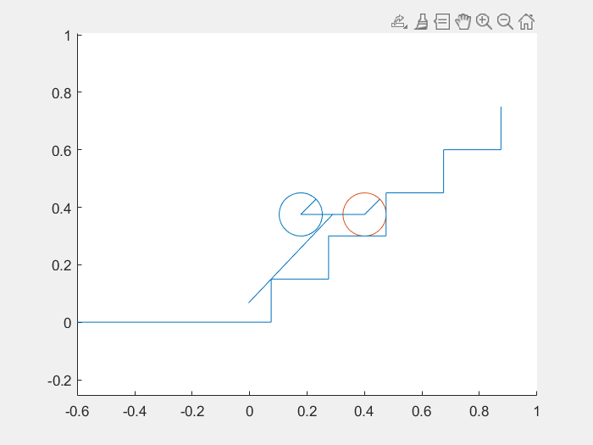

The MATLAB solve function had several limitations, it struggled to solve nonlinear equations that use trigonometry. Simply implementing a sine function in one equation will cause the solver to stall when finding a solution, even when the angle is fully defined in another equation. Because of this, I implemented a function to solve the set of equations using substitutions. It takes some time to solve the system of equations, but it does so reliably.

I have started writing my report, I created an outline for each chapter and have begun writing the earlier sections.

I have started with the analysis of my recorded data. I have found that the discrepancy between the recorded data and the model is greater when using the lower gear ratio. I have a theory for why this is, the calibration of the motor involves it lifting a mass until the gearbox locks. The lower gear ratio motor is faster so builds up some momentum in this motion, causing it to lift higher than it otherwise should. I may need to reassess my calibration, or simply stick to using the higher gear ratio motors. To do the latter, I would need to provide a lower voltage to the motor than what my motor controller can output, which I could do with a lab bench supply, or by dropping the motor voltage using resistors/diodes.

Another possible cause for discrepancies could be that the masses were calibrated incorrectly. I used a kitchen scale to measure the masses of the components for convenience, but I will seek out a more accurate scale from the university store.

Another potential source of error is that I do not currently model the small amount of slipping that the front wheel does when lifting. This could be solved by observing when the wheel slips and updating the model to slip under the same conditions.

Another source of error comes from the gearbox. The locked gears require a certain amount of torque to overcome, which is not modelled in the math or the simulation.

One major discrepancy between the maths model and the recorded data is that the maths model indicates that the torque needed to lift the LIMs decreases as the LIM lifts higher, this makes sense as the lever effect of gravity is highest when horizontal. However, both the real device and the simulation show partial lifting for certain torques, i.e. the device begins to lift but does not lift the whole way, indicating that some point in the lifting motion requires more torque than the horizontal case. This may be due to incorrect assumptions in the maths model.

# What I’m working on next:

Model validation: I will perform additional experiments using the higher gear ratio motor with a lower voltage, as this may confirm that there was a problem with the calibration of the lower gear ratio motor. I will measure the masses of the device more accurately. I will perform further analysis on the experimental data obtained so that I can make conclusions about the accuracy of the simulation and math model.

Improve models: I will investigate the assumptions that lead to the model acting differently to the real device in terms of partial lifting.

-----------------------------------------------------------------------------------------------------------------

Unchanged:

Next iteration: While building and testing the device I have been considering potential improvements for a future version. If time allows, I would like to build a second device after I have validated the model using the first device. The design of this device would consider lessons learned from the model, and multiple concepts could be quickly tested in simulation. The ideas I’m currently pondering include using bearings, herringbone gears, brushless dc motors, and possibly even connecting the two LIMs together with a bolt so they move rigidly together, eliminating the possibility that one moves ahead of the other.